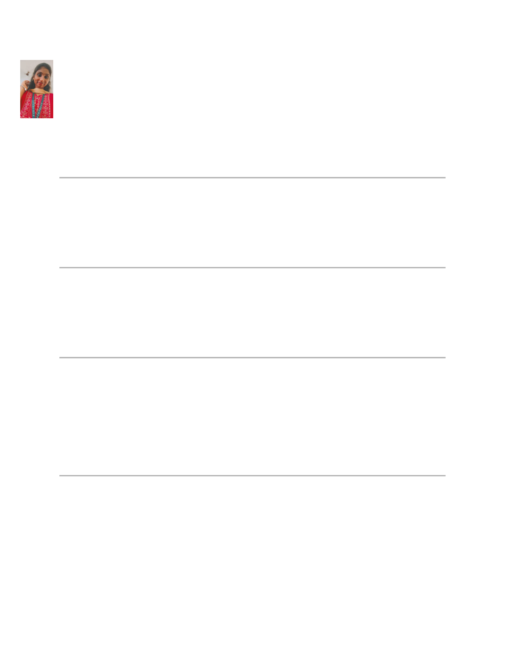

**RESUME**

**K.A.Ramya**

**ncas2326se1030@ncas.in (222303584)**

**About me**

Result -driven computer science professional with experience in software development, system

design, and data analysis.passionate about leveraging technology to develop innovative solution

s and improve efficiency in software development process

**Education**

**BSC in computer science**

University of madras, Year of Graduation 2026

**key skills**

• Software optics

• Os developer

• IOT science

• python

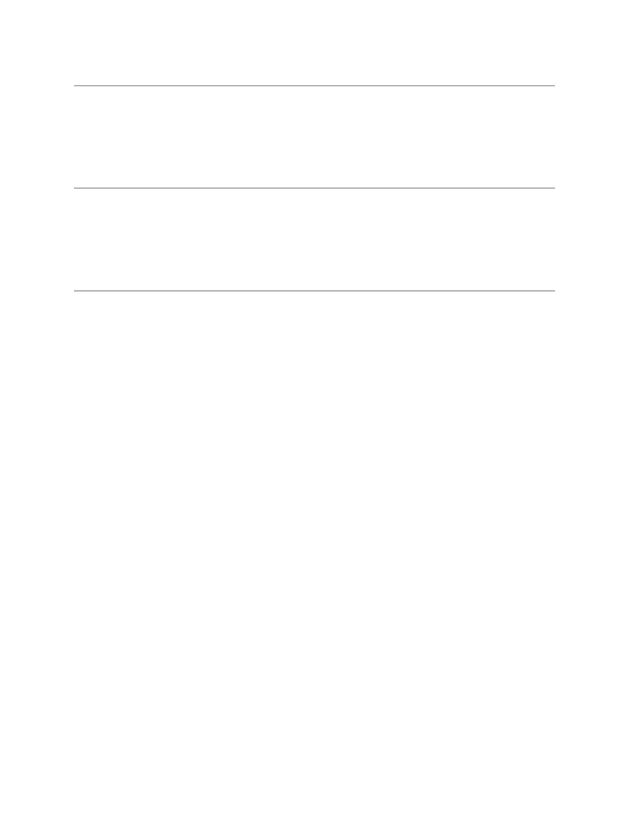

**Certifications & Training**

• [IOT], saveetha arts and science [2023]

• [bug correction in game backend], Activision – call of duty, [2024]

**Projects & Achievements**

• **Hack deduction AI** :worked on hack deduction AI of Activsion organization.

• **Home automation:** have a brief experience in IOT home Automation.

**Languages**

• Tamil – mother tongue

• [English - advance